Lola’s Learning

Game Design Document

**Executive Summary:**

* Overview: The main character, Lola, has to wander through classrooms and answer questions to proceed to the next room. All the classrooms are the same, except they slowly deteriorate into a horror-looking room. It is almost as if the character is going through a nightmare. If Lola gets a question right, she is rewarded. If she gets the question wrong, the nightmare becomes more visible and she will eventually have to run away from a monster.
* Story of Game: (Story)
* Related Games: Baldy’s Basics
* The World: A school classroom / an alternate dark-realm

Room design is similar to the one below (not exactly, but like a rectangular room with a door but doors are locked until you complete your task in the room)

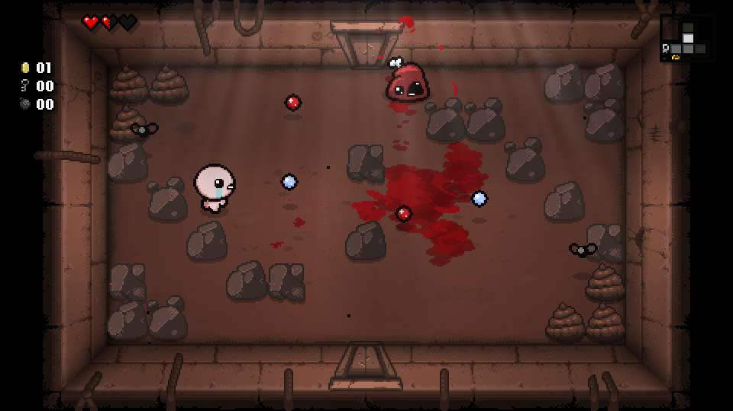

* Main Character: Lola
* Enemies: The monster
* Main Game Mechanics: Moving with the arrow keys, typing or clicking on answers, running away from the monster, unlocking rooms by getting questions right, etc
* Character Goals: Answer the questions right, escape from this nightmare
* Game Win: Escape the monster/ defeat the monster / answer all the questions right / escape the nightmare
* Game Loss: Get eaten by the nightmare monster

**User Interface Mock-up(s):**

* Flowchart

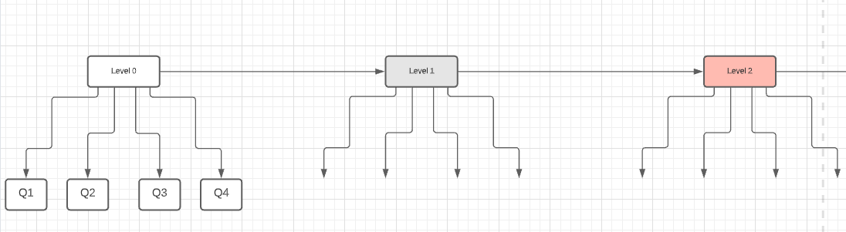

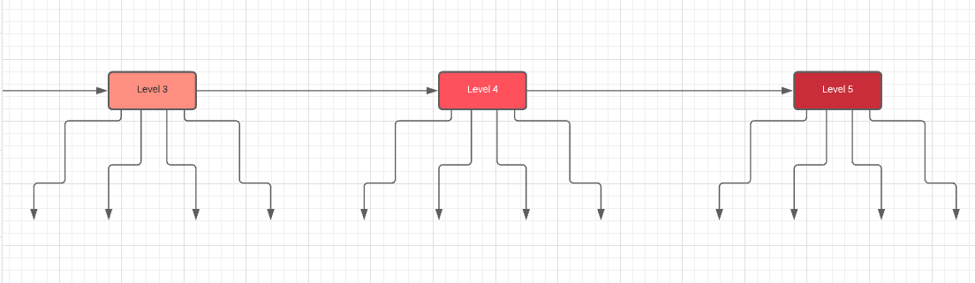

* Character design:

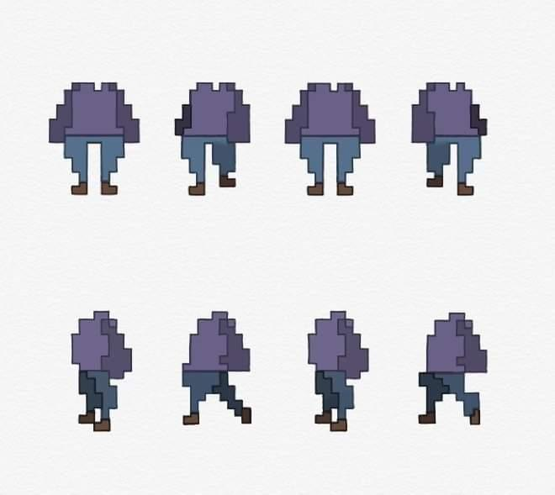

**Controls:**

* ARROW KEYS to move
* SPACE BAR to interact
* MOUSE to interact with questions

**Levels Details:**

* Level 1:
* Subject: Math
* Questions: 4
* Level 2:
* Subject: Art
* Questions: 4
* Level 3:
* Subject: English
* Questions: 4
* Level 4:
* Subject: Philosophy
* Questions: 4
* Level 5:
* Subject: Science
* Questions: 4
* Level 6:
* Subject: Physical Educations
* Questions: 4

**Score System:**

The score will be called ‘Grade’ in the game. Your grade will start at 100%. The grade will only be deducted if the player gets a question wrong. Otherwise the grade will remain the same. If you get a question wrong 10 points will be deducted.

**Developer Roles:**

* Doreen Ansah:
  + Sound Engineer
  + Level Designer
  + Game Designer
  + Programmer
* Amanda De Rosa:
  + Head Programmer
  + Game Artist
* Emma Florent:
  + Sound Engineer
  + Level Designer
  + Game Designer
  + Programmer

**Schedule of Releases:**

* 11/16: Prototype (initial draft)
  + Accomplishments:
* 11/23: First playable (look and gameplay integrated)
  + Accomplishments:
* 11/30: Pre-Alpha (all characters and levels integrated)
  + Accomplishments:
* 12/07: Alpha (will be shared for testing)
  + Accomplishments:
* 12/13: Gold Master (final version)
  + Accomplishments: